**SUSTAINABLE SUPPLY CHAIN PERFORMANCE DASHBOARD IN POWER BI**



**( WEEK – 1 )**

In this Week – 1 project, I’ve done the task by the following steps:

1. Open Power BI

2. Select **Get Data** option to select your file.

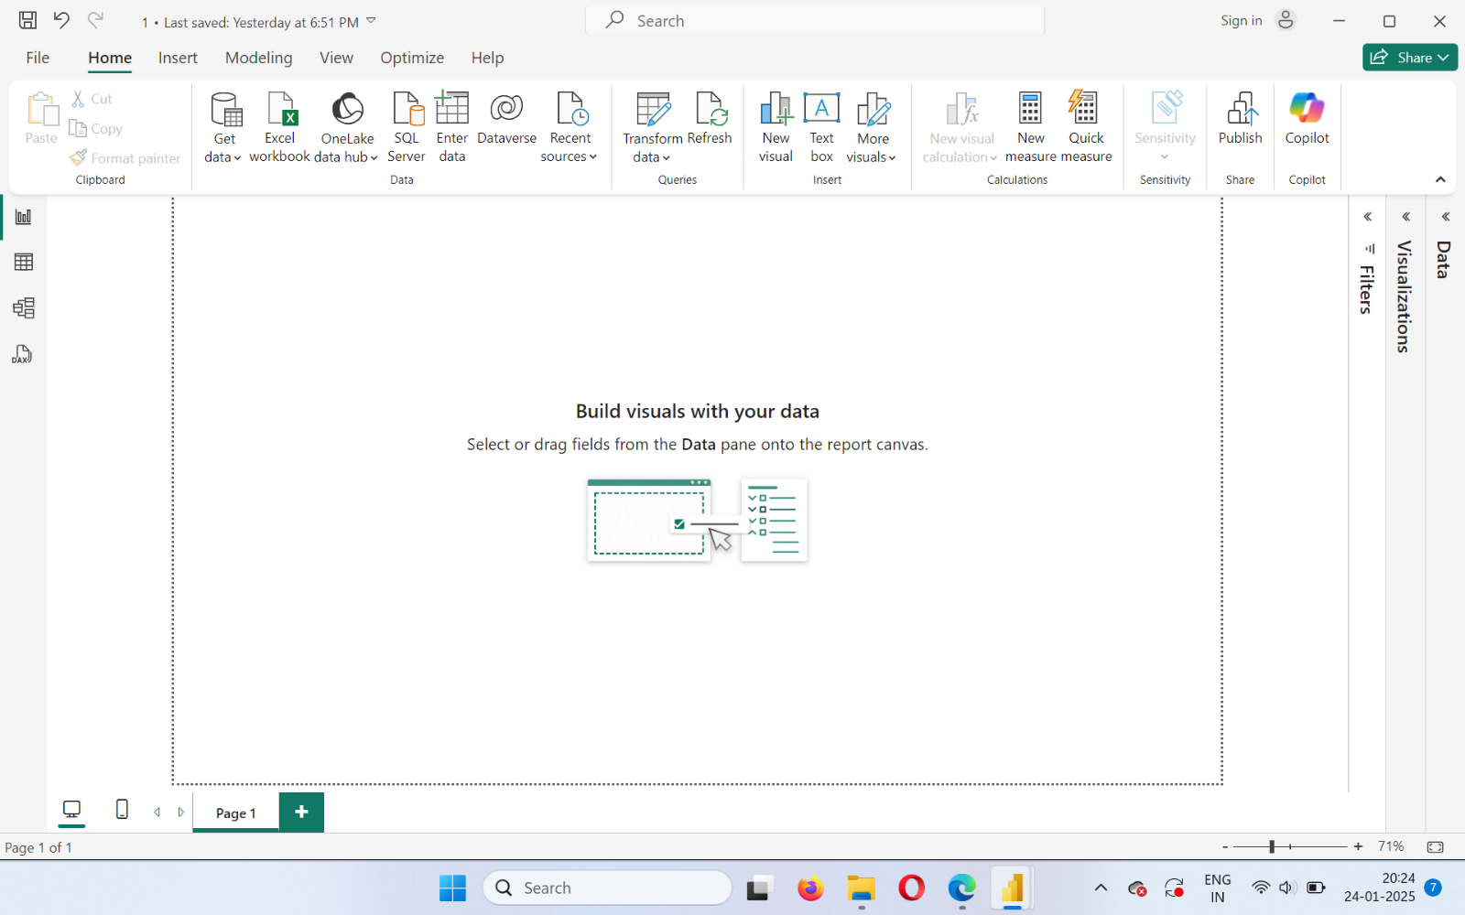

3. Choose what kind of file you want to upload into the Power BI. Whether it can be in Excel format or in JSON or in PDF format. Here we are using the CSV ( Comma – Separated Values ) format.

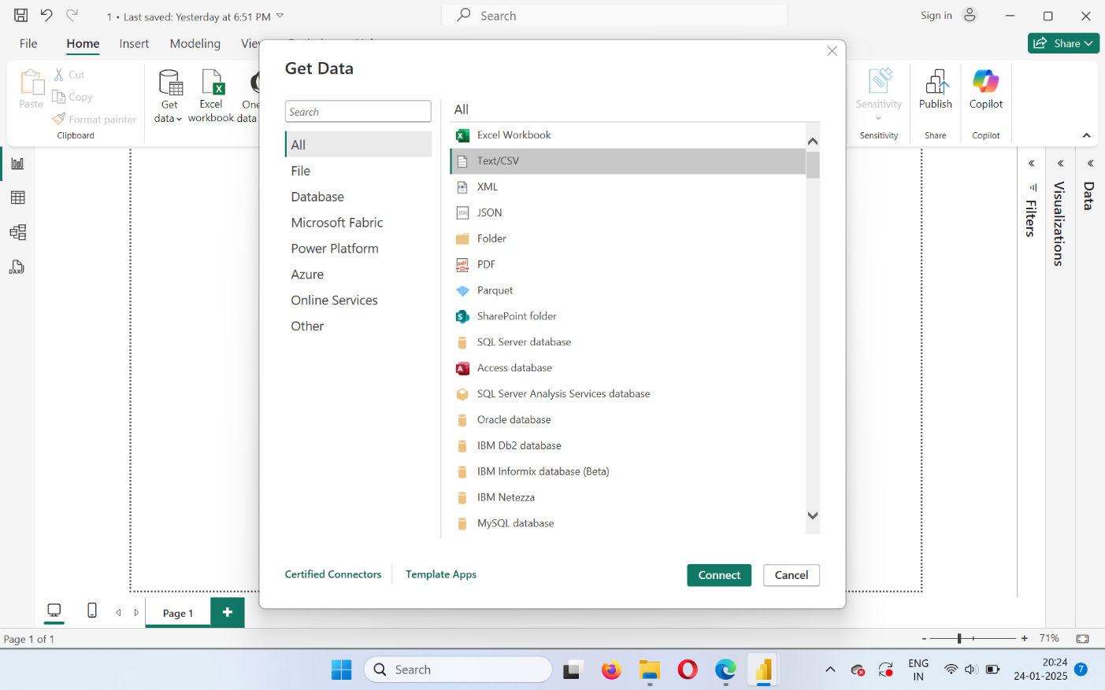



4. After choosing your file, **Load** your file onto the Power BI. Even after loading the data you can transform the data.

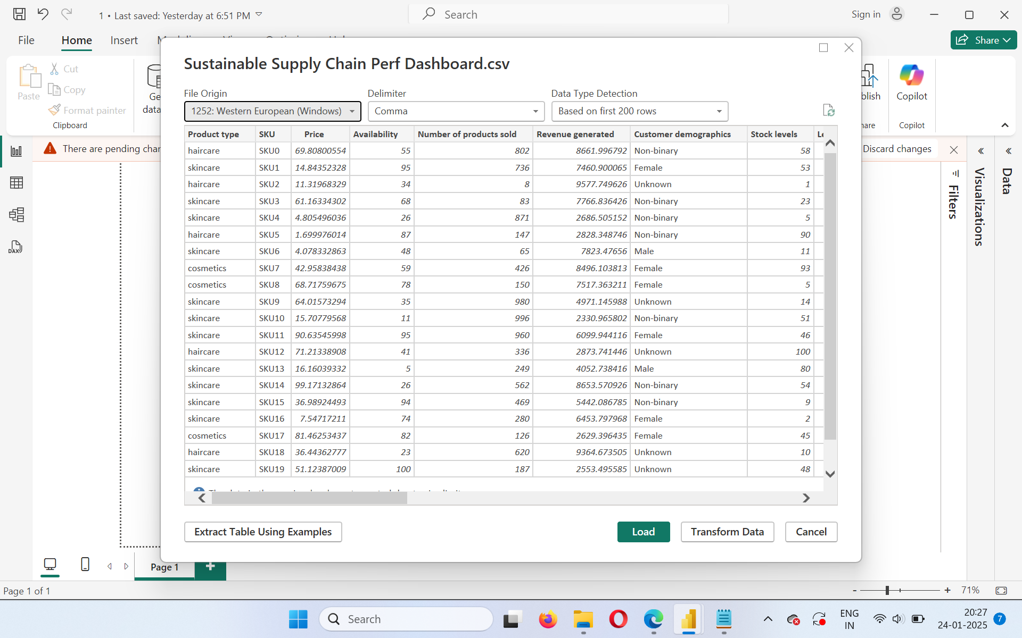

5. After loading the file, click on **Transform Data** option, in which you can transform your data and check is there is any errors or duplicate values or any null values.



6. After transforming your data, You’ll be moved to the **Power Query Editor.** In the Power Query Editor, Click on the view tab. After clicking on it, select  **Column Quality** checkbox. So that you could view what are all the errors, duplicates and null values are there in your file.

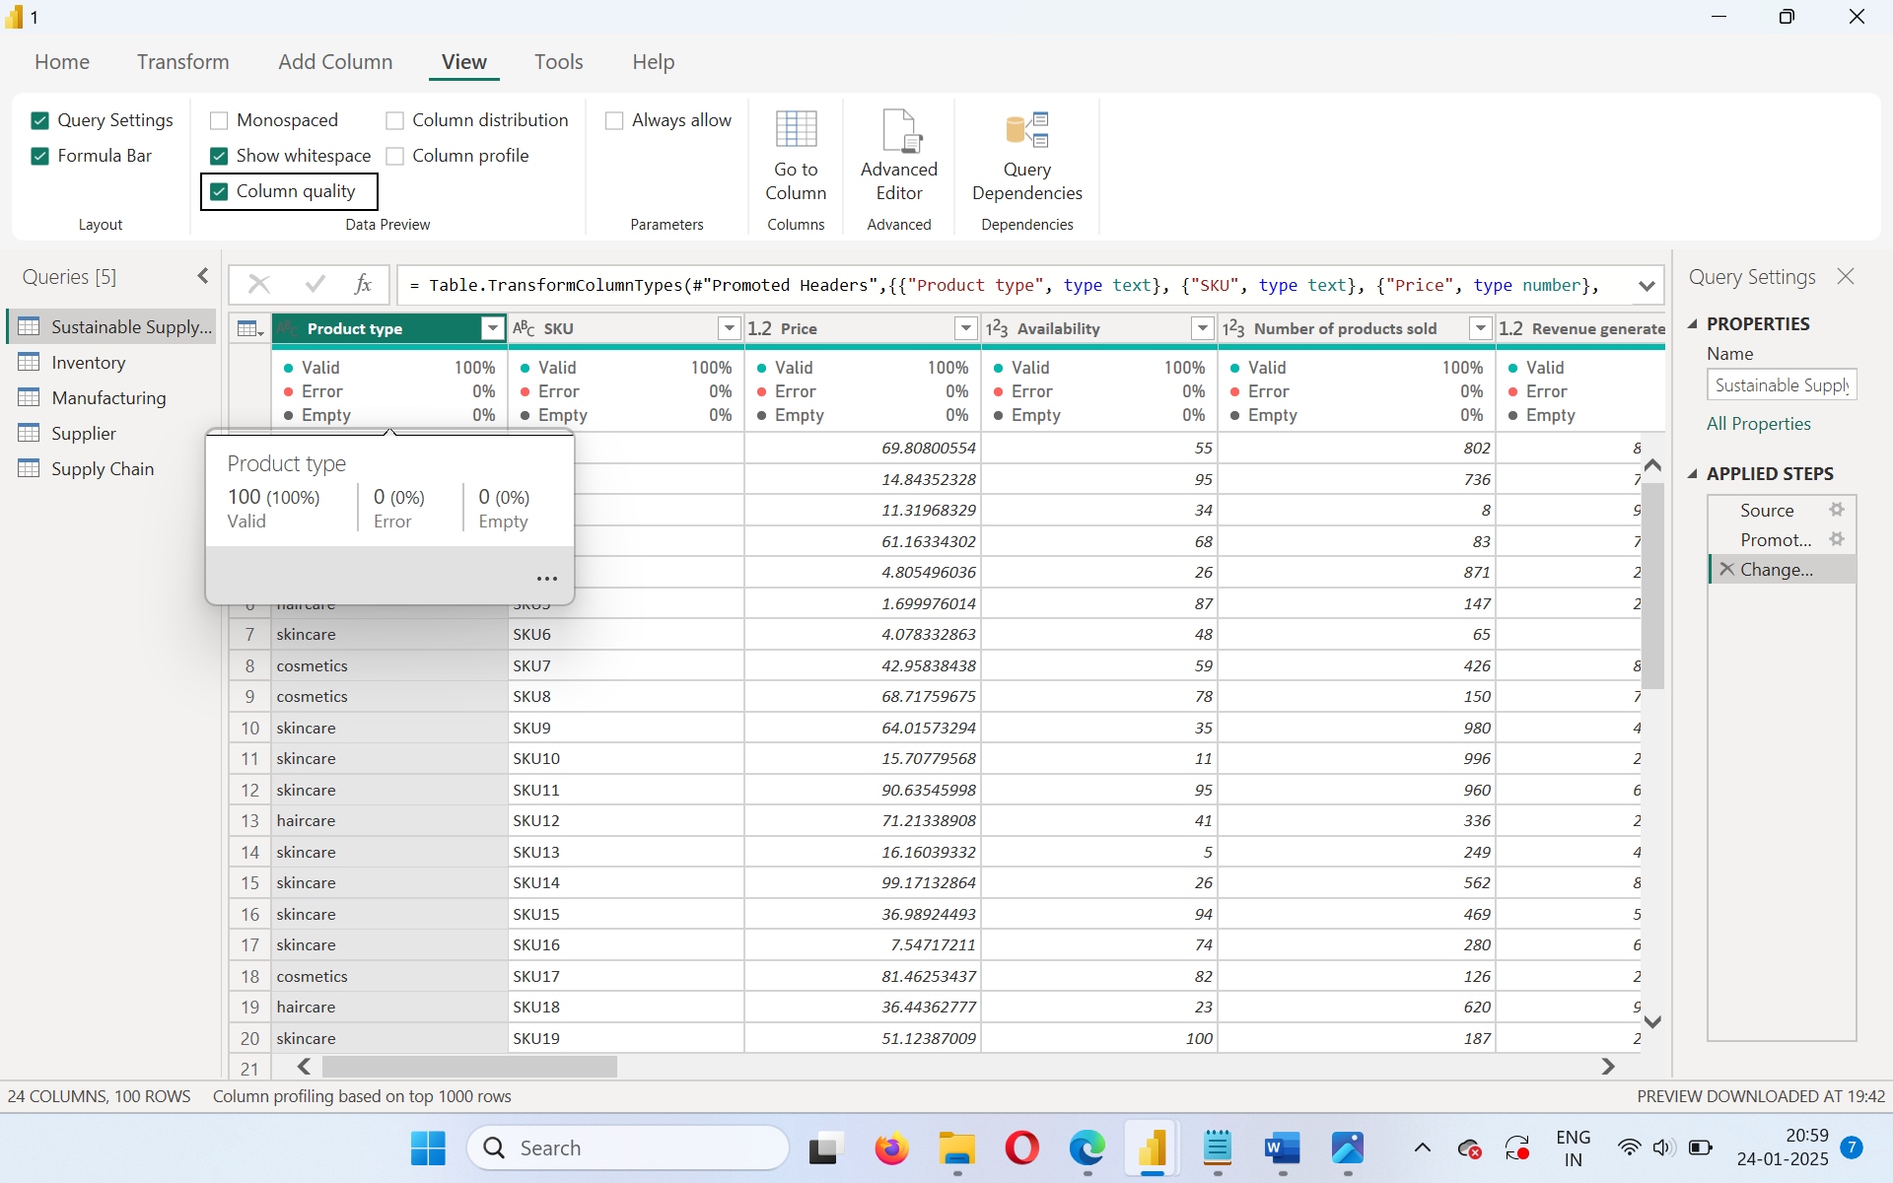

Here, it shows 0% error and 0% empty on all columns. So we’re on the right track.

7. The task begins here, We’ve to create 4 tables named : Inventory, Manufacturing, Supplier, Supply Chain. We create these tables by duplicating the original table again and again. After duplicating these, we’ve to rename those tables to the specified one.

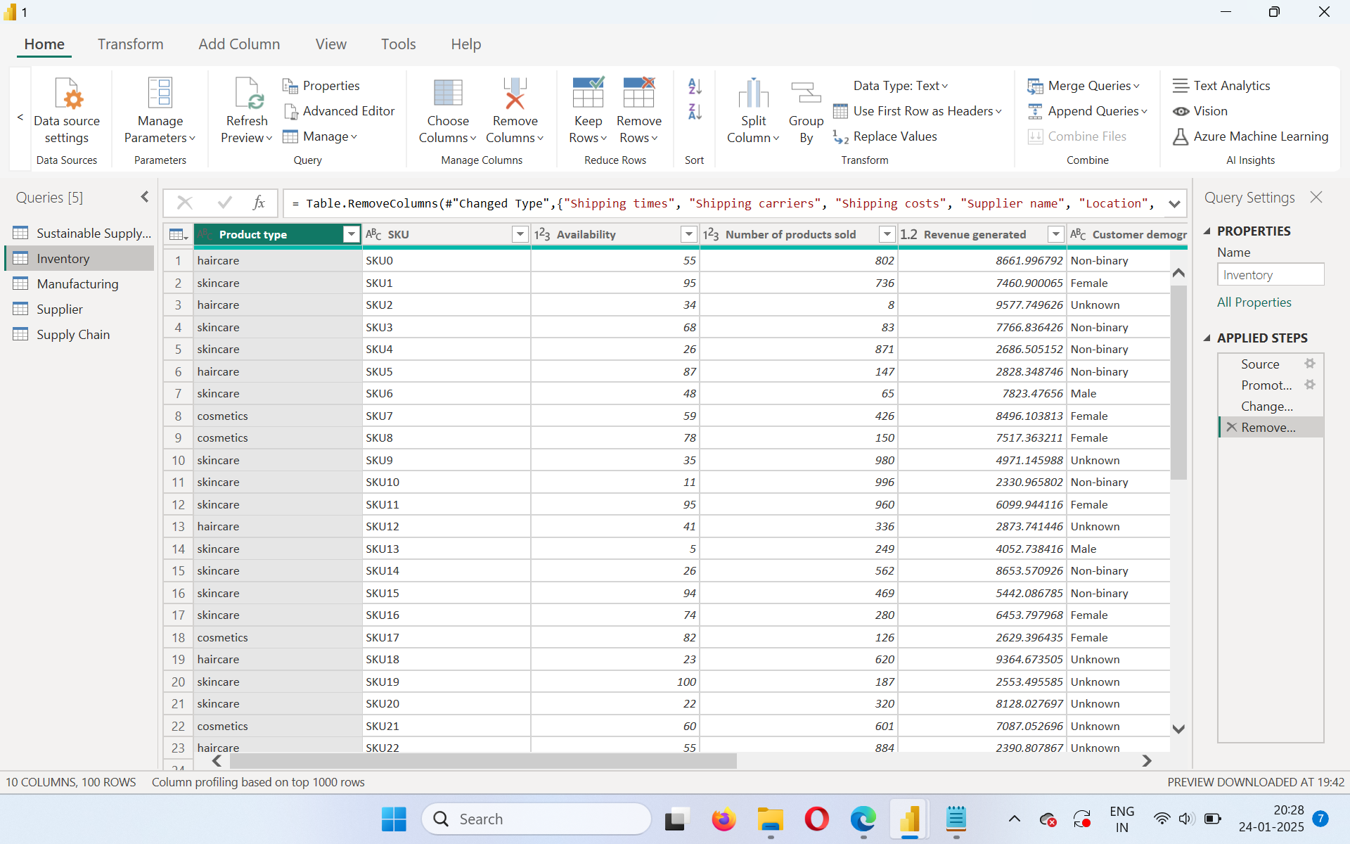8. After renaming the tables, remove the unnecessary rows. After removing the unnecessary rows, the tables will look like this:

i)

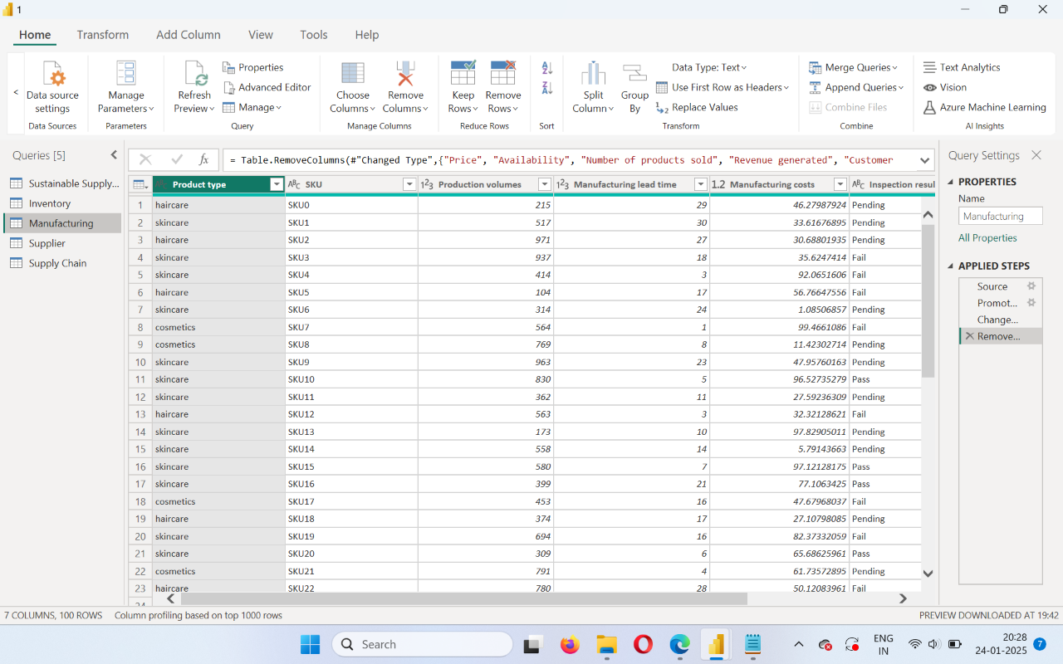ii)

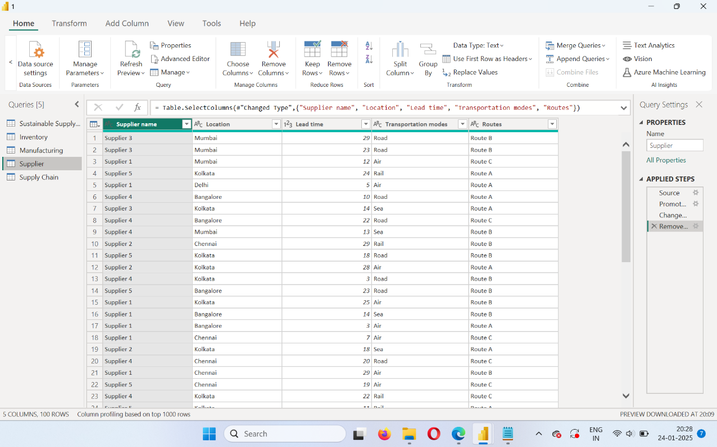

iii)

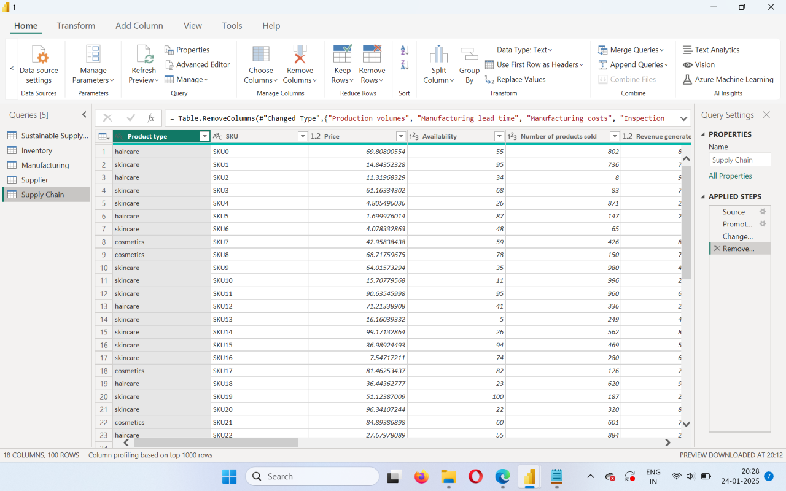

iv)

9. Once you’ve done removing the unnecessary elements. Save the Power BI file in your desired location by clicking the close and apply button on the top leftmost corner.

And that’s all about the task.

Thank you for this wonderful opportunity.

With Sincere Regards,

Aksetha B

Student ID: STU6767b990d43fa1734850960